

**Video Conferencing Systems**

**Requirements Analysis Document**

Prof. Dr. Hasan ERBAY

Dr. Abdülvahhap Ömer TOPRAK

**170444027 - Ilgın GÜRSOY**

**180444044 - Mustafa Emirhan ALKAN**

CONTENTS

1 Introduction 2

1.1 Purpose of the system 3

1.2 Scope of the system 3

1.3 Objectives and success criteria of the Project 3

1.4 Definitions, acronyms, and abbreviations 3

1.5 References 3

2 Current System 3

3 Proposed system 5

3.1 Overview 5

3.2 Functional requirements ("shall lists") 5

3.3 Nonfunctional requirements 5

3.3.1 Usability 5

3.3.2 Reliability 6

3.3.3 Performance 6

3.3.4 Supportability 6

3.3.5 Implementation 6

3.3.6 Interface 6

3.3.7 Packaging 6

3.3.8 Legal 6

3.4 System models 6

3.4.1 Scenarios 6

3.4.2 Use case model 7

3.4.3 Analysis object model 7

3.4.4 Dynamic model 7

3.4.5 User interface—navigational paths and screen mock-ups 7

4 Glossary 8

# Introduction

## Purpose of the system

All of the online education systems used today are designed using similar templates to each other. These designs are quite complex and difficult-to-use interface designs, especially for children between the ages of 6-11. In addition, not all of the systems offered offer different activities that children can reach except for the purpose of online lessons. With this online tutoring and activity system, a more understandable and easy-to-use interface and extracurricular activities are offered for children of the specified age group.

## Scope of the system

This system includes educational games, stories and reading texts that children can access during extracurricular times, along with a convenient interface for children between the ages of 6 and 11. The games on the system are games designed to support the development of children by using their intelligence and skills. The reading texts, on the other hand, consist of stories and fairy tales with different difficulties and themes, taking into account the age of the children.

## Objectives and success criteria of the Project

The success of the project is to create a convenient and understandable interface for children aged 6-11 and to provide activities to help children develop their intelligence and skills during extracurricular times.

## Definitions, acronyms, and abbreviations

Video Conferencing System (VCS)

## References

* <https://www.videonations.co.uk/resources/blog/a-history-of-video-conferencing/>
* [https://en.wikipedia.org/wiki/](https://en.wikipedia.org/wiki/Skype)

## Overview

This RAD is arranged into two parts. The first is the overall description and second section is the Specific Requirements.

# Current System

**ZOOM;**

Zoom Video Communications, Inc. (commonly shortened to Zoom, and stylized as zoom) is an American communications technology company headquartered in San Jose, California. It provides videotelephony and online chat services through a cloud-based peer-to-peer software platform and is used for teleconferencing, telecommuting, distance education, and social relations.

**Pros:** Screen sharing; creating breakout rooms, recording meetings.

**Cons:** Not very easy to use, free plan has time limit.

**Price:** Available for free.

**Establishment Date:** 2012

**Google Hangouts;**

**Pros:** Easy to use both desktop and mobile.

**Cons:** A Google account is required to start the meeting.

**Price:** Available for free.

**Establishment Date:** 2013

**Skype;**

First released in August 2003, Skype was the creation of Niklas Zennström and Janus Friis, in cooperation with four Estonian developers. In September 2005, eBay acquired Skype for $2.6 billion. Skype is a proprietary telecommunications application that specializes in providing VoIP-based videotelephony, videoconferencing and voice calls. It also has instant messaging, file transfer, debit-based calls to landline and mobile telephones (over traditional telephone networks), and other features. Skype is available on various desktop, mobile and video game console platforms, and is operated by Skype Technologies, a division of Microsoft.

**Pros:** You can use it for free with any time and user.

**Cons:** Old, bulky and not very efficient.

**Price:** Available for free.

**Establishment Date:** 2003

**Programming Languages:** C++, Objective-C, Delphi, Object Pascal

**Microsoft Teams;**

Microsoft Teams is a proprietary business communication platform developed by Microsoft, as part of the Microsoft 365 family of products. Teams primarily competes with the similar service Slack, offering workspace chat and videoconferencing, file storage, and application integration. It was designed by Microsoft as a competitor to Slack and was officially announced in November 2016. Microsoft Teams is a web-based desktop application. It was developed on the Electron framework from GitHub.

**Pros:** Lots of features like background blur, chat function and integrated apps

**Cons:** Features don't work very well.

**Price:** Free for those with an Office 365 subscription.

**Establishment Date:** 2016

**Programming Languages:** Electron, React, TypeScript, Angular.

# Proposed system

## Overview

With the advancement of technology, many children are able to follow technologies and developments, but the situations we need to deal with are about what they can do when learning a new program and when they encounter problems in this program. Today, many young people have attention deficit. They feel bad about not being able to cope with difficulties. Most of the currently used and common video conferencing systems and applications have been established to appeal to a wide range of ages, and there are systems that are complex. Our aim is to design a program for a narrower age range, primary school students, to make it easier to use and to make the design more special. In addition, there are educational games, books and articles for students to improve themselves outside of online education.

## Functional requirements ("shall lists")

* Admins, Teachers and students logins system.
* Extracurricular reading books for students
* Extracurricular educational games for students
* A course system where students and teachers can participate online and live at the same time.

## Nonfunctional requirements

### Usability

* Application has Graphical User interface, Users can use application with mouse.
* Moving between pages is very easy and fast.
* Easy access to extracurricular educational activities.

### Reliability

* Every user has unique usernames, they can login with them.
* Password reset enable and third time wrong password locks his/her login page.
* Every data stores in database and it cannot access without application.

### Performance

### Supportability

* More additional functionalities can add or remove this application.
* Addition and subtraction can be done in extracurricular activities.

### Implementation

* For the system will be written using HTML and CSS, it can be used on all operating systems and devices.

### Interface

The general view of the project is in the image below.

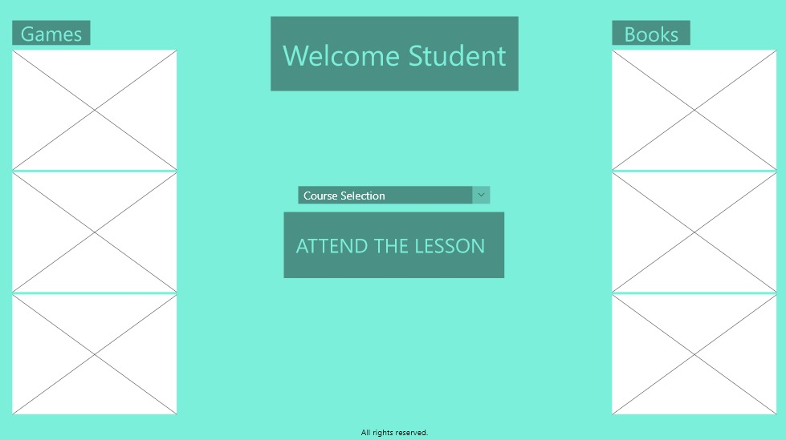

The part where extracurricular educational books and articles are included.

The part where extracurricular educational games take place.

The part where they will log in to the live lesson.

### Packaging

### Legal

## System models

### Scenarios

|  |  |
| --- | --- |
| **Scenario name:** | Register |
| **Participating actor İnstances:** | Albert (Student) |
| **Flow of events:** | 1) Albert is a student who wants to register in the system.  Therefore, he needs to register. He opens the application and sees the login and registration page, clicks register.  2) Name, surname of the applicant,  Username, Password, gender and security. The question is about Albert (if he forgets the password). And that's how he registers in the system. |

|  |  |
| --- | --- |
| **Scenario name:** | Opening an online class |
| **Participating actor İnstances:** | Daisy (Teacher) |
| **Flow of events:** | Daisy has the right to open a classroom because she has registered as a teacher in the system. First, you enter the system, then you select the name of the course by clicking the open course button, invite the participants and open the course in this way. |

|  |  |
| --- | --- |
| **Scenario name:** | Using extracurricular educational activities |
| **Participating actor İnstances:** | Albert (Student) |
| **Flow of events:** | After logging in to the system, Albert can use these educational activities by selecting the one he wants from the games and books section on the main page. In addition, he can pick up where he left off because the system detects his previous activities and books he has read. |

### Use case model

### Analysis object model

### Dynamic model

### User interface—navigational paths and screen mock-ups

# Glossary

* CSS : CSS, an abbreviation of the words Cascading Style Sheets, which means Cascading Style Sheets, allows you to edit more eye-catching parts of a website. To modify colors, interface arrangements, fonts and many related visual design elements is working.
* HTML : Html, the markup language, is the system used for the preparation of web pages. Html, which is not a programming language, is used to create websites that we use on our computers. Browsers such as Chrome, Fİrefox and Internet Explorer process html codes and convert these codes to a web page.
* Object Pascal : [Turbo Pascal](https://tr.wikipedia.org/wiki/Pascal_programlama_dili)'dan sonra [Borland](https://tr.wikipedia.org/wiki/Borland" \o "Borland) firmasının çıkardığı bir [programlama dilidir](https://tr.wikipedia.org/wiki/Programlama_dilleri). [Delphi](https://tr.wikipedia.org/wiki/Delphi" \o "Delphi) isimli geliştirme ortamının da temel aldığı nesne yönelimli programlama dilidir.